

SIMATS ENGINEERING

Saveetha Institute of Medical and Technical Sciences
Chennai- 602105

Student Name: sreelatha.k Reg. No.: 192425248
Course Code: MLA0408 Slot: C
Course Name: Deep Learning
Course Faculty: Dr.D Sudhagar
Project Title:
Deep Learning Based Real-Time Driver Drowsiness Detection and Alert System.
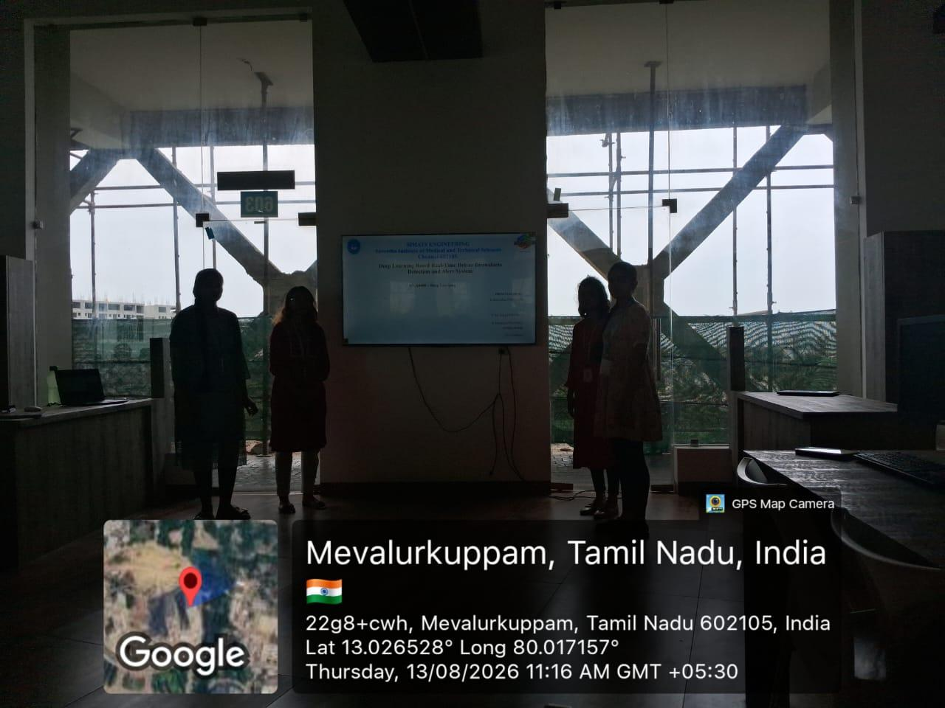
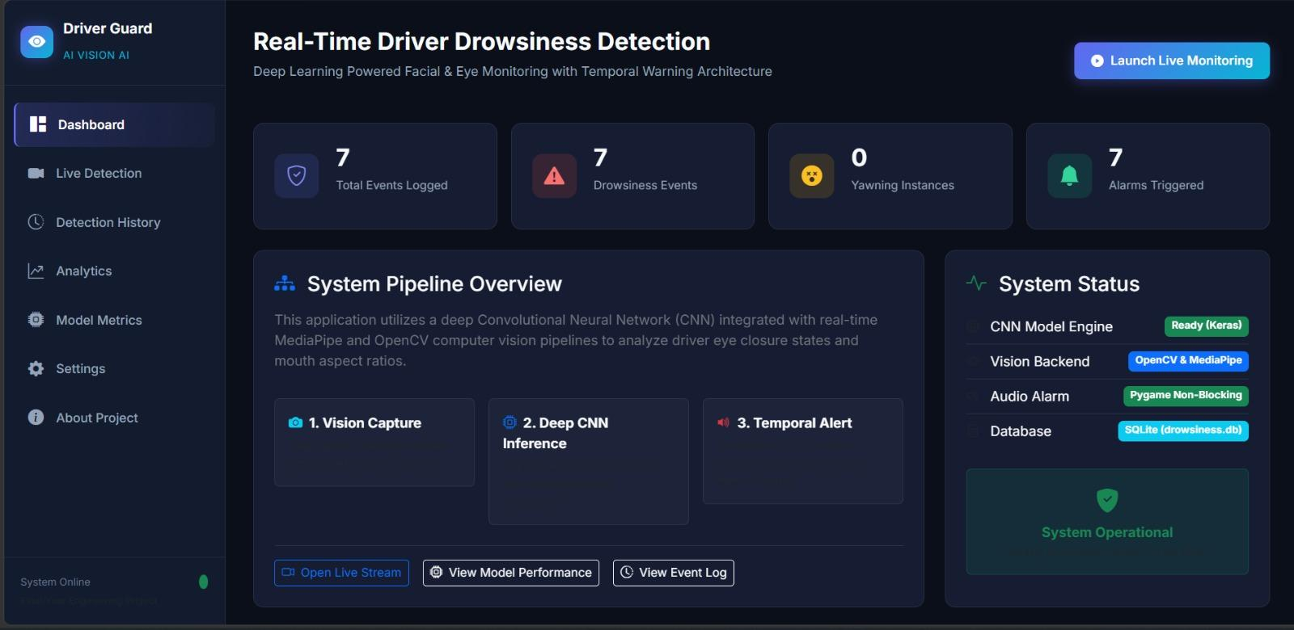
Project Description:
The Deep Learning Based Real-Time Driver Drowsiness Detection and Alert System is designed to detect whether a driver is alert or drowsy using a camera and deep learning. The system continuously captures the driver's face and analyzes features such as eye closure, blinking, and yawning. When drowsiness is detected, the system provides an immediate alert to warn the driver and improve road safety..

Module: Deep Learning Model
This module develops and trains a deep learning model to identify the driver's alert and drowsy conditions from facial images. The preprocessed images are provided as input to the model, which learns important facial features such as eye closure, blinking, and yawning. The model is trained using labeled data and its performance is evaluated using suitable accuracy and loss metrics. After successful training, the model is saved and integrated with the real-time detection module. The trained model can then classify the driver's condition as alert or drowsy based on the captured camera frames.

Student Signature Guide Signature

